May Elementary School
Suggested Supply List for 2022–2023
The Clark County School District provides necessary supplies for all
students in order to meet their educational needs. However, we know
that sometimes parents choose to buy school supplies for their child.
Should you decide to do this, the following are items by grade level.

1st Grade
1 large box of Kleenex
1 backpack (with child’s name on it) (No wheels)
1 pair of Fiskar scissors
2 boxes of crayons (16 or 24 pack)
1 package of #2 pencils
1 pencil box
1 pack of highlighter - yellow
1 reams of copy paper
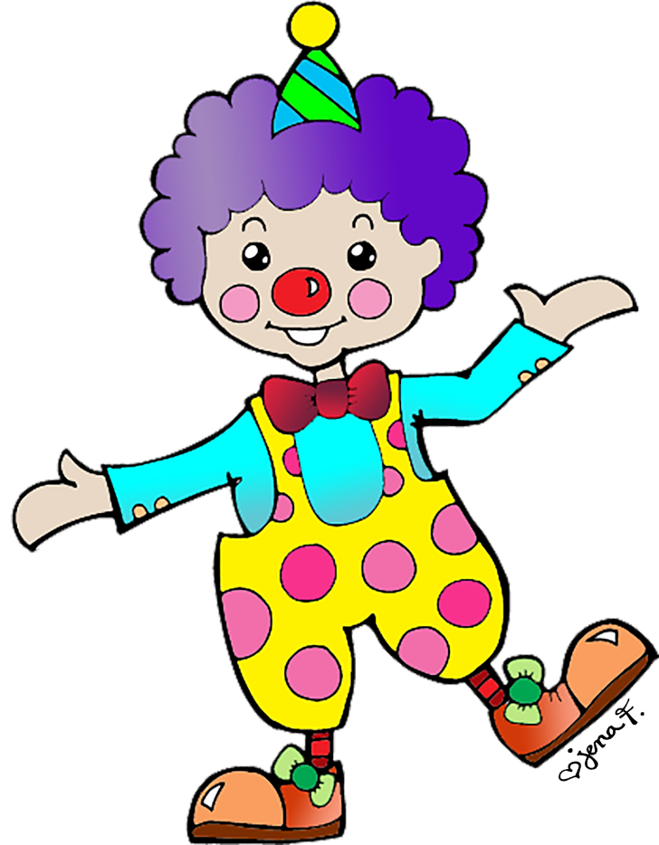
4 black expo dry erase markers
10 glue sticks - large
1 container of disinfectant wipes
1 bottle of hand sanitizer
1 box of gallon size Ziploc bags
1 box of snack size Ziploc bags
1 headphones (No earbuds)

